**\*Structure And There Attribute\***

**Name:Ravi Prakash Zanke.**

**Proff.: Vinayak Sir.**

**Topic:Structure 2.**

**Assignment Date:22/04/23**

**<………………………………………………………………………………………………………………..>**

**1.Student.**

#include<stdio.h>

#include<string.h>

typedef struct student

{

char name[50];

char gender[50];

float marks;

int rollnum;

}student;

void store(student*,int);

void display(student*,int);

void main()

{

int n,i;

puts("Enter Numbers of Entry u want for Student:");

scanf("%d",&n);

student arr[n];

store(arr,n);

display(arr,n);

}

void store(student* arr,int n)

{

int i;

puts("........Hey Answer The Below Question.........");

for(i=0;i<n;i++)

{

puts("........................................................................");

printf("Enter Name of The Student %d :",i+1);

scanf("%s",&arr[i].name);

printf("Enter Roll Number of Student %d :",i+1);

scanf("%d",&arr[i].rollnum);

printf("Enter Gender of Student %d :",i+1);

scanf("%s",&arr[i].gender);

printf("Enter Marks of Student %d :",i+1);

scanf("%f",&arr[i].marks);

fflush(stdin);

}

}

void display(student* a,int n)

{

puts("\n Hey ur Entered Details are");

int i;

for(i=0;i<n;i++)

{

puts("\n........................................................................");

printf("\nStudent %d Name :%s",i+1,a[i].name);

printf("\nStudent %d Roll number :%d",i+1,a[i].rollnum);

printf("\nStudent %d Gender :%s",i+1,a[i].gender);

printf("\nStudent %d Marks :%.2f %%",i+1,a[i].marks);

}

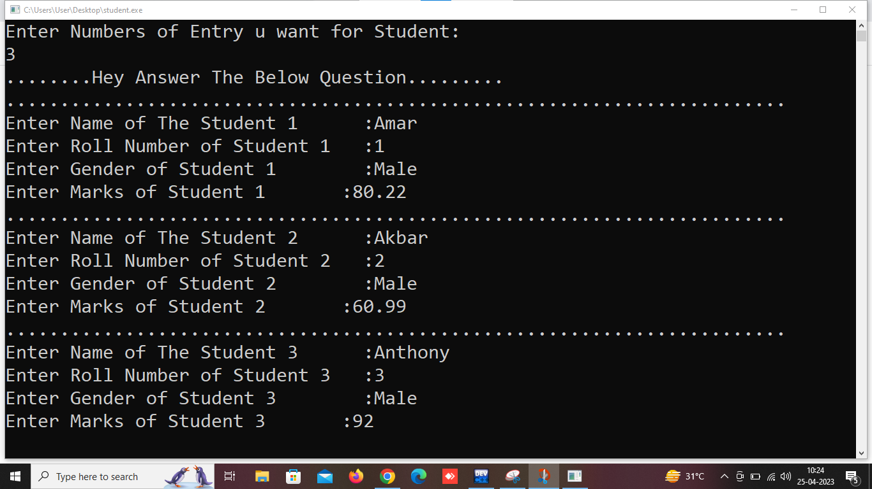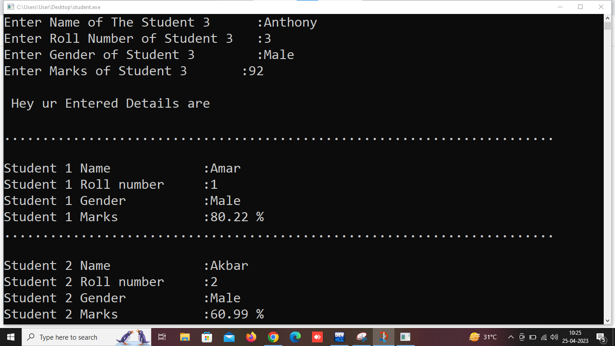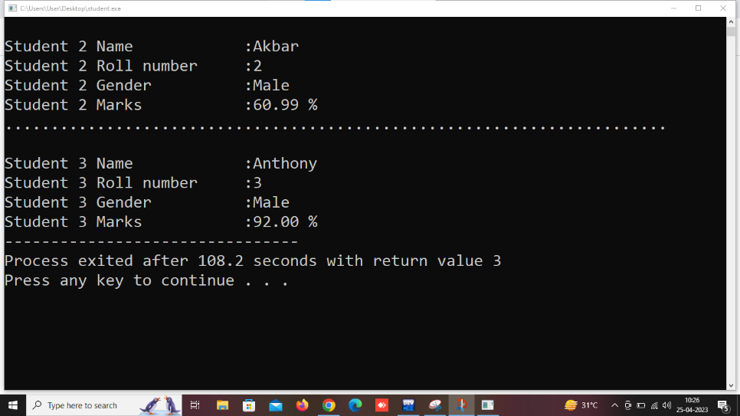

**<………………………………………………………………………………………………………………..>**

**2.Book.**

#include<stdio.h>

#include<string.h>

typedef struct book

{

char bname[50];

char author[50];

float price;

float id;

}book;

void store(book*,int);

void display(book*,int);

void main()

{

int n,i;

puts("Enter Numbers of Entry u want for Books:");

scanf("%d",&n);

book arr[n];

store(arr,n);

display(arr,n);

}

void store(book* arr,int n)

{

int i;

puts("........Hey Answer The Below Question.........");

for(i=0;i<n;i++)

{

puts("........................................................................");

printf("Enter Name of The Book %d :",i+1);

scanf("%s",&arr[i].bname);

printf("Enter id Number of book %d :",i+1);

scanf("%f",&arr[i].id);

fflush(stdin);

printf("Enter Name of Author for book %d :",i+1);

gets(arr[i].author);

printf("Enter Price of book %d :",i+1);

scanf("%f",&arr[i].price);

}

}

void display(book* a,int n)

{

puts("\n Hey ur Entered Details are");

int i;

for(i=0;i<n;i++)

{

puts("\n........................................................................");

printf("\nBook %d Name :%s",i+1,a[i].bname);

printf("\nBook %d Id :%.2f",i+1,a[i].id);

printf("\nBook %d Author :%s",i+1,a[i].author);

printf("\nPrice Of Book %d :%.2f Only/-",i+1,a[i].price);

}

}

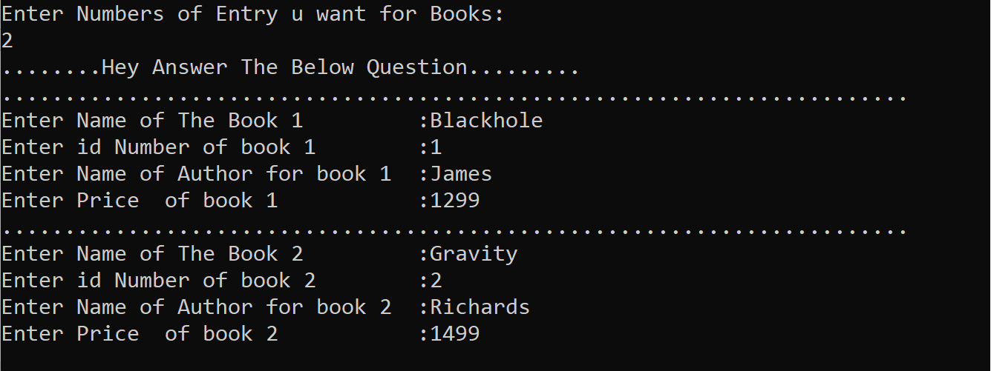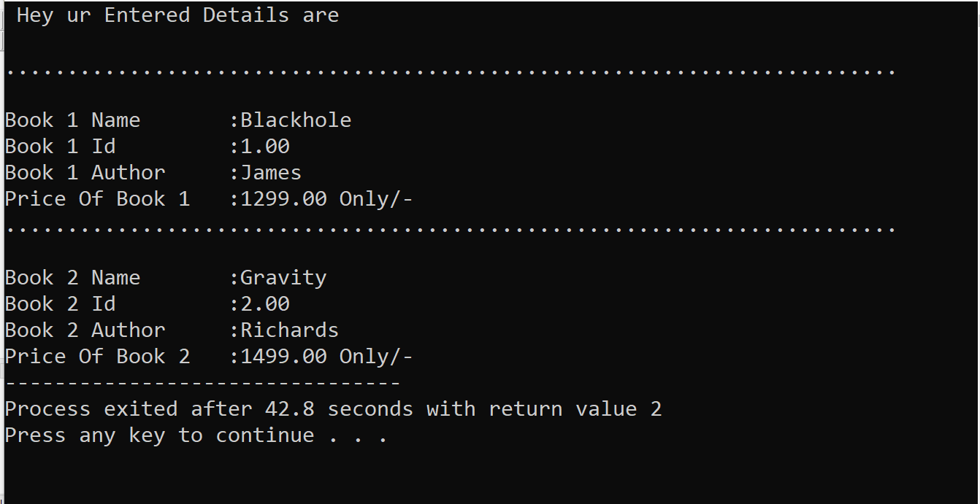

**<………………………………………………………………………………………………………………..>**

**3.Time.**

#include<stdio.h>

#include<string.h>

typedef struct Time

{

int hour,minute,second;

}Time;

void display(Time*,int);

void store(Time*,int);

void add(Time*,int);

void main()

{

int n,r1,r2;

puts("Enter number of Data u want to Enter for time:");

scanf("%d",&n);

Time a[n];

store(a,n);

display(a,n);

add(a,n);

}

void store(Time* a,int n)

{

//int i,th,tm,ts;

int i;

for(i=0;i<n;i++)

{

puts(".....................................................");

printf("Enter the Time%d Hour :",i+1);

scanf("%d",&a[i].hour);

printf("Enter the Time%d Minute :",i+1);

scanf("%d",&a[i].minute);

printf("Enter the Time%d Second :",i+1);

scanf("%d",&a[i].second);

}

}

void display(Time * t,int n)

{

int i;

puts(".............................................");

printf("\nTime:Hours|Minutes|Seconds");

for(i=0;i<n;i++)

{

printf("\n %d | %d | %d ",i+1,t[i].hour,t[i].minute,t[i].second);

}

}

void add(Time* t,int n)

{

int i1,i2;

int i ,hour=0,minute=0,second=0;

for(i=0;i<n;i++)

{

hour = hour + t[i].hour;

minute = minute + t[i].minute;

second = second +t[i].second;

}

if (minute>=60)

{

hour = hour + minute/60.;

minute = minute%60;

}

if (second>=60)

{

minute = minute + minute/60;

second = second%60;

}

puts("\n....................................................");

printf("\nTotal Time:\nHours |Minutes |Seconds");

printf("\n %d %d %d ",hour,minute,second);

puts("\n....................................................");

i=0;

printf("\nAddition of Particular time");

puts("\nEnter any two Time Number u want to Add in Particular:");

scanf("%d%d",&i1,&i2);

int hr=t[i1-1].hour+t[i2-1].hour;

int min=t[i1-1].minute+t[i2-1].minute;

int sec=t[i1-1].second+t[i2-1].second;

if(sec>59)

{

min=min+1;

sec=sec-60;

}

if(min>59)

{

hr=hr+1;

min=min-60;

}

printf("\nTotal of Particular Selected Time Number Entry:\nHours|Minutes|Seconds");

printf("\n %d %d %d ",hr,min,sec);

}

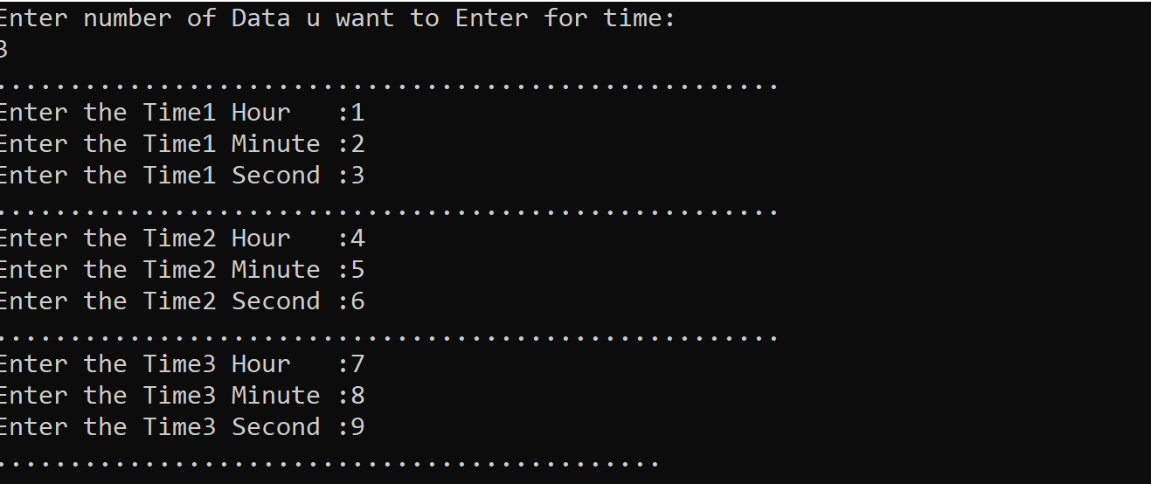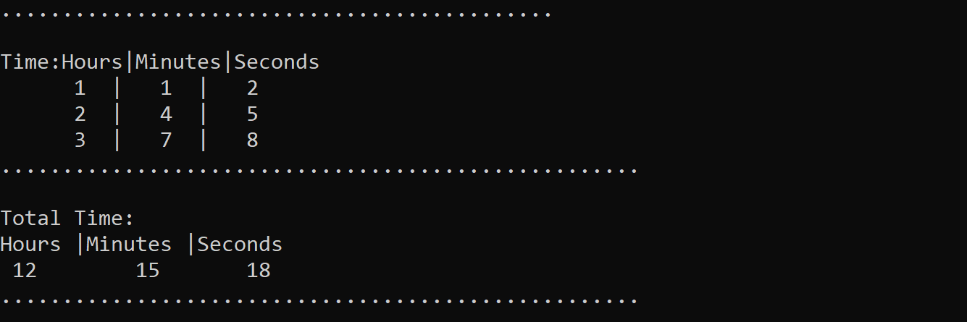

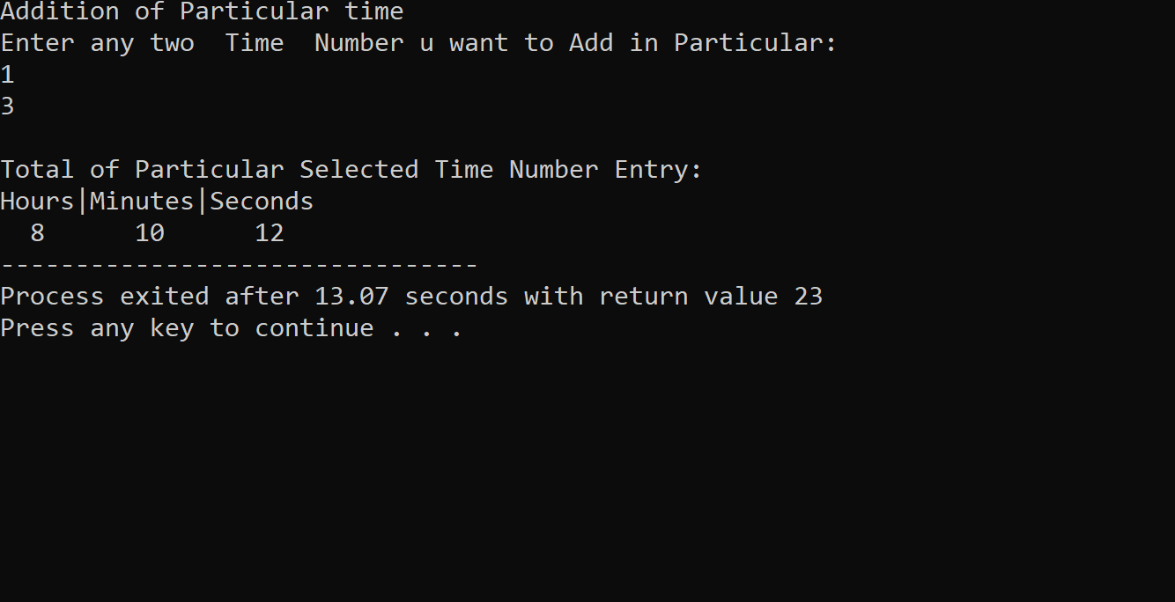

**<………………………………………………………………………………………………………………..>**

**4.Player.**

#include<stdio.h>

#include<string.h>

typedef struct player

{

char name[50];

//char num[50];

int num;

int runs;

int wickets;

}player;

void store(player*,int);

void display(player*,int);

void maxrun_wicket(player*,int);

void main()

{

int n,i;

puts("Enter Numbers of Entry u want for Players:");

scanf("%d",&n);

player arr[n];

store(arr,n);

display(arr,n);

maxrun_wicket(arr,n);

}

void store(player* arr,int n)

{

int i;

puts("........Hey Answer The Below Question.........");

for(i=0;i<n;i++)

{

puts("........................................................................");

printf("Enter Name of The Player %d :",i+1);

scanf("%s",&arr[i].name);

printf("Enter Jersey Number of player%d :",i+1);

scanf("%d",&arr[i].num);

printf("Enter Runs By Player %d :",i+1);

scanf("%d",&arr[i].runs);

printf("Enter Wickets By player %d :",i+1);

scanf("%d",&arr[i].wickets);

//fflush(stdin);

}

}

void display(player* a,int n)

{

puts("\n Hey ur Entered Details are");

int i;

for(i=0;i<n;i++)

{

puts("\n........................................................................");

printf("\nPlayer %d Name :%s",i+1,a[i].name);

printf("\nPlayer %d Jersey Number :%d",i+1,a[i].num);

printf("\nPlayer %d Runs :%d",i+1,a[i].runs);

printf("\nPlayer %d Wickets :%d",i+1,a[i].wickets);

}

}

void maxrun_wicket(player* a,int n)

{

int i,maxrun,maxwicket;

maxrun=a[0].runs;

maxwicket=a[0].wickets;

for(i=0;i<n;i++)

{

if(a[i].runs>maxrun)

{

maxrun=a[i].runs;

}

}

for(i=0;i<n;i++)

{

if(maxrun==a[i].runs)

{

puts("\n........................................................................");

puts("\n........Most run By Player is Mentioned Below:.........");

printf("\nPlayer %d Name :%s",i+1,a[i].name);

printf("\nPlayer %d Jersey Number :%d",i+1,a[i].num);

printf("\nPlayer %d Runs :%d",i+1,a[i].runs);

printf("\nPlayer %d Wickets :%d",i+1,a[i].wickets);

}

}

for(i=0;i<n;i++)

{

if(a[i].wickets>maxwicket)

{

maxwicket=a[i].wickets;

}

}

for(i=0;i<n;i++)

{

if(maxwicket==a[i].wickets)

{

puts("\n........................................................................");

puts("\n........Most Wicket By Player is Mentioned Below:.........");

printf("\nPlayer %d Name :%s",i+1,a[i].name);

printf("\nPlayer %d Jersey Number :%d",i+1,a[i].num);

printf("\nPlayer %d Runs :%d",i+1,a[i].runs);

printf("\nPlayer %d Wickets :%d",i+1,a[i].wickets);

}

}

}

